Agile Methodologies

Tarun Verma

A00258754

Reflective Essay

Newspaper Delivery System

**Objective**

The objective of this assignment is to develop User Stories for the Newspaper Delivery System. It has to be done as a group project, so I was part of a four members team where we have to create user stories based on the client requirements. Basic requirements given by the client included the following:

* Create an automated system for managing Newspaper Delivery.
* Create relevant features to manage certain books that client has to maintain manually namely, Customer Book, Order Book and Delivery Book.
* Provide functionality for recording daily deliveries in the form of Delivery Dockets.
* A way to manage Delivery persons assigned to different areas and the deliveries they have to do.
* Creating and maintaining Invoice journal for each customer to generate final Bill at the month end.

Client gave us all the details of his work that he does manually till now, which we have to automate.

Now, our objective was not only to cover all the client’s requirements and develop the user stories for the system, but also to do the same as a team. This would help all the members to learn how to work in a group with proper planning, sharing opinions with each other and managing conflicts that occur during discussions.

Also, we were to maintain an individual Learning Log which contains our goals, contribution and some other parameters for every group meeting. It was completely a learning exercise to help us understand how Agile methodology works in real.

**Working**

In the **First** meeting, we started our discussion with analyzing all the user requirements and clearing each other’s doubts. We had to work together so I came up with the idea of dividing the set of requirements into different phases which we would cover in separate meetings. The phases finalized were Authentication phase, Book keeping phase, Delivery phase and Billing phase. We decided that everyone will cover some feature in each phase at one meeting, so that every member will have equal contribution.

As decided, **second** meeting was to work on Authentication phase. At this point we get to know that one of our members has dropped out so instead of reacting we decided to go as planned and divided the work to the remaining members. After having discussion, we finalized to limit the number of users for the system to two that is Admin and Store manager. I worked on the functionality that allows store manager to login into the system. While others created user stories for registering the store manager into the system and providing him alert notification for unauthorized access.

We completed our assigned portion of work in second meeting, so **third** meeting was to work on Book keeping phase. Having open discussions with the team helped me to work more effectively as it helps to see different aspects of a problem and different solutions which in turn leads to a better result. We discussed the flow of system as how client used to manually manage his books, and how they are interrelated with each other. We end up with three categories of books, namely Customer Book, Order Book and Delivery Book. I took the responsibility of Order book and created the user story for adding an Order book for a customer. While other members worked on remaining books.

**Fourth** meeting was to work on Delivery phase of the system which includes creating delivery dockets for each delivery person that contains all the details of the deliveries that has to be made on a day. Since I was left with some of my features from Order Book, I worked on it while other members created user stories for delivery phase. However, I took part in discussion as to how delivery phase would be managed, which turns out that we had missed Invoice journal in book keeping phase.

On our **Fifth** and almost last meeting, we worked on Billing phase, where we created features for managing invoice journal, generating monthly bill and providing appropriate reminders/notices if any. I worked on creating the Invoice journal in book keeping phase. During our discussion, we found out that there are certain points which were still unclear to us, so we fixed our meeting with the client.

After the meeting with the client, we finally had our **last** meeting where we added features for a new user of the system which is the delivery person. Since it was not a huge amount of task so we divided the work among two members where I got the authentication part and one member worked on the delivery part. We left the final review responsibility to the third member which he performed quite well.

**Process Learning Criteria**

|  |  |  |
| --- | --- | --- |
| **Criteria Descriptor** | **Well Achieved/ Achieved/ Not Achieved** | **Justification** |
| **Setting (Plan) Achievable Goals - Group** | Well achieved | Strategy was to set group goals which can be achieved easily within the timeframe, and they were successfully achieved which can be seen in learning log as well. |
| **Setting (Plan) Achievable Goals - Individual** | Well achieved | Individual goals were also not set to too much work for an individual and everyone did achieve their individual goals on time. |
| **Individual Role within Group (Interpersonal Skills)** | Well achieved | Actively took part in every discussion and contributed several ideas that were implemented in the project and showed the skills like conflict management, trust building when discussions were contradicting. The same is reflected in learning log as well. |
| **Quality and content of contribution – (Group / Individual)** | Well achieved | Contributed actively to the project with some great ideas keeping every member in mind. Provided ideas to other members as well, which was not the part of own work. |
| **Learning Log (Refer to guidelines below)** | Well achieved | Learning Log Entry completed as per guidelines and version controlled after each piece of work undertaken. |
| **Reaching Achievable Goals - Group** | Well achieved | Group goals clearly reached within planned timeframe, main reason for this was that we tried to target small amount of work which can be completed easily without giving burden to any member. |
| **Reaching Achievable Goals - Individual** | Achieved | Individual goals were reached most of the time within planned timeframe except once because of engaging in some other task. However, it didn’t affect group goals at all. |

**Content Learning Criteria**

|  |  |  |
| --- | --- | --- |
| **Criteria Descriptor** | **Well Achieved/ Achieved/ Not Achieved** | **Justification and Example** |
| **Independent** | Well achieved | All the User Stories are able to stand alone. Each user story is a feature or a component of a feature that can be tested and implemented as a unique element, and can be delivered in any order. It can be seen in below example: |
| **Negotiable** | Well achieved | Almost every user story was collaborative and open to discussions about the best way to solve the business problem, as each member was working as a part of same project so somehow, they were interested in how the system flow is working. And provided their opinions on every user story created. |
| **Valuable** | Well achieved. | Each story added some value to the system. No story is irrelevant. Below example shows the same: |
| **Estimatable** | Well achieved | Each user story is Estimatable. There is no big user story that is difficult to understand which can be seen in the product backlog. Each user story consists of acceptance criteria which can be used to estimate the time required by developers. Example below: |
| **Small** | Well achieved | Each user story was created keeping in mind the fact that it should be created within a single sprint.  For example: |
| **Testable** | Well achieved | Each story has some feature in it which is described well and can be tested independently with the help of user acceptance criterions defined.  Example of acceptance criterions defined: |
| **Who, What, and Why** | Well achieved | For all User Stories, the Who, What, and Why are clearly identifiable.    Who: incorporates the perspective of the person who will use or benefit from the requested feature. Defined clearly in each user story.  What: is a description of the requested feature that is short and simple. Described briefly for every user story.    Why: incorporates the “value” of the feature so the team can understand what is driving this particular request. Defined in each story.  Example below clearly shows Who, What and Why for the user story. |

**Git history of Learning Log submissions**

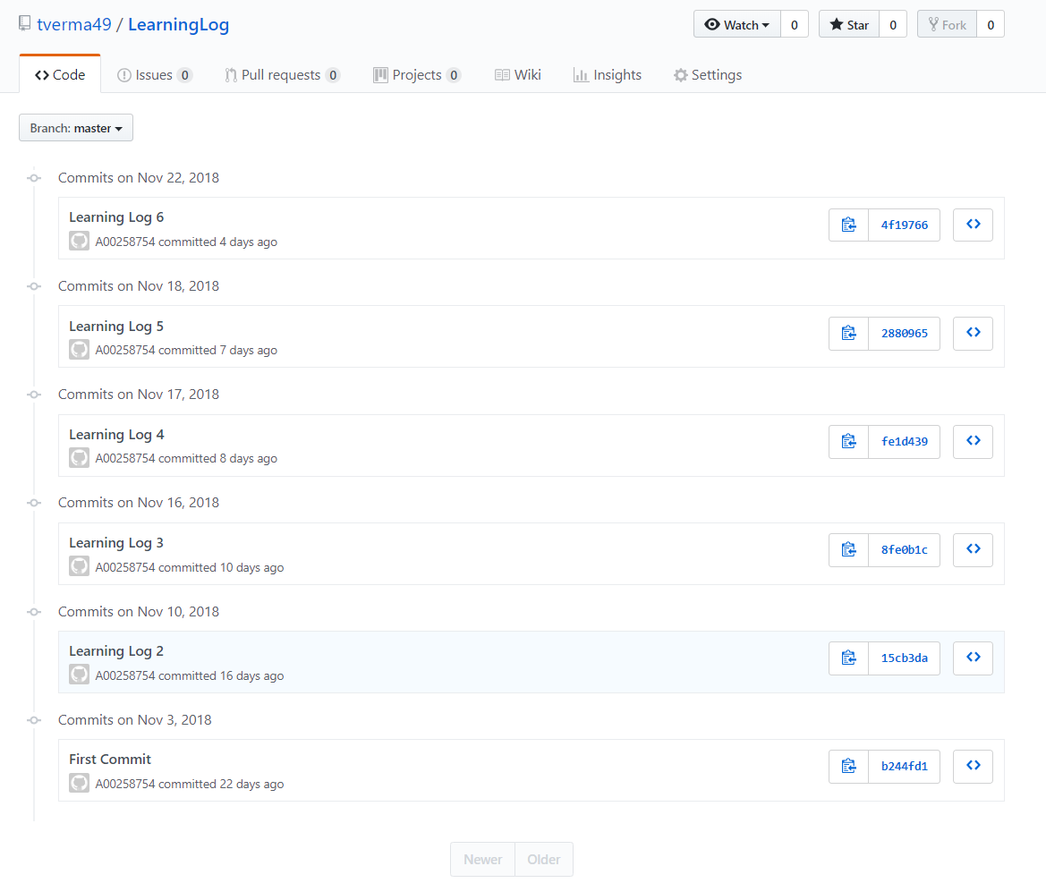

**Product Backlog Contributions**

My product backlog contributions are clearly described in the Learning Logs attached with this document.